**GovTech Location Decision Maker API Specification**

**APIs are categorized into 4 based on functionality modules**

**No of APIs:** 19

1. **User**

**Description**: To manage user related functionalities like sign up, find users to send invitation for a session, fetch user details by id and account id

**No of APIs**: 4

1. **Account**

**Description**: To manage account related functionalities like sign in, forgot password, change password, reset password and get account details by id

**No of APIs**: 5

1. **Session**

**Description**: To manage session related functionalities like create session, invite users into a session, update session, delete session, retrieve session details, retrieve session invited users and find sessions

**No of APIs**: 7

1. **Restaurant**

**Description**: To manage restaurant related functionalities like suggest a restaurant to a session, fetch suggested restaurants for a session and select a random restaurant from suggested restaurants

**No of APIs**: 3

1. **User Management APIs:**

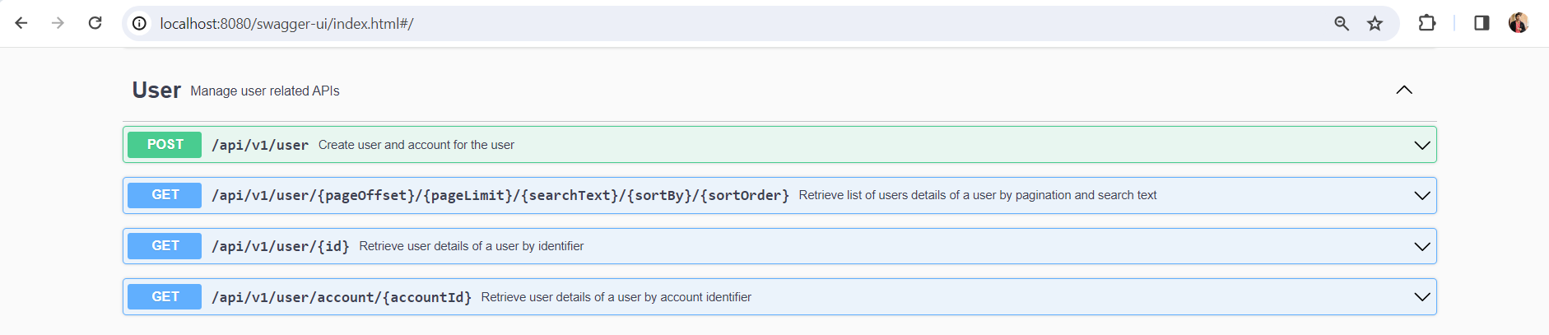

* 1. **POST**[**/api/v1/user**](http://localhost:8080/swagger-ui/index.html#/User/create)

**Description**: Create user and account for the user

* 1. **GET**[**/api/v1/user/{pageOffset}/{pageLimit}/{searchText}/{sortBy}/{sortOrder}**](http://localhost:8080/swagger-ui/index.html#/User/find)

**Description**: Retrieve list of users details of a user by pagination and search text

* 1. **GET**[**/api/v1/user/{id}**](http://localhost:8080/swagger-ui/index.html#/User/getById)

**Description**: Retrieve user details of a user by identifier

* 1. **GET**[**/api/v1/user/account/{accountId}**](http://localhost:8080/swagger-ui/index.html#/User/getByAccountId)

**Description**: Retrieve user details of a user by account identifier

1. **Account Management APIs:**

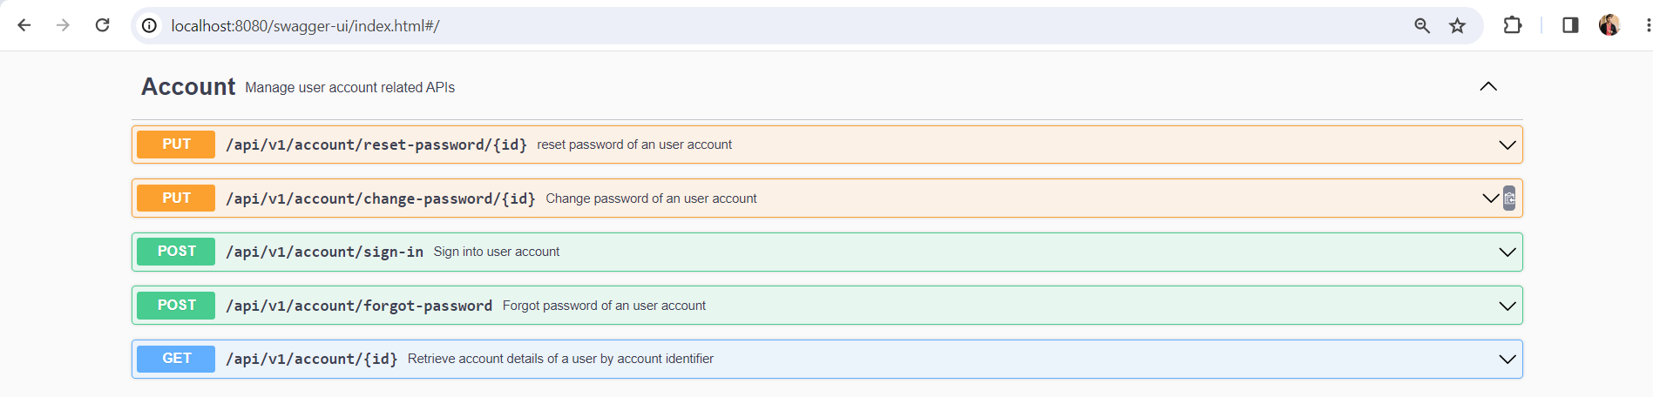

* 1. **PUT**[**/api/v1/account/reset-password/{id}**](http://localhost:8080/swagger-ui/index.html#/Account/resetPassword)

**Description**: reset password of a user account

* 1. **PUT**[**/api/v1/account/change-password/{id}**](http://localhost:8080/swagger-ui/index.html#/Account/changePassword)

**Description**: Change password of a user account

* 1. **POST**[**/api/v1/account/sign-in**](http://localhost:8080/swagger-ui/index.html#/Account/signInAccount)

**Description**: Sign into user account

* 1. **POST**[**/api/v1/account/forgot-password**](http://localhost:8080/swagger-ui/index.html#/Account/forgotPassword)

**Description**: Forgot password of a user account

* 1. **GET**[**/api/v1/account/{id}**](http://localhost:8080/swagger-ui/index.html#/Account/getByAccountId_1)

**Description**: Retrieve account details of a user by account identifier

1. **Session Management APIs:**

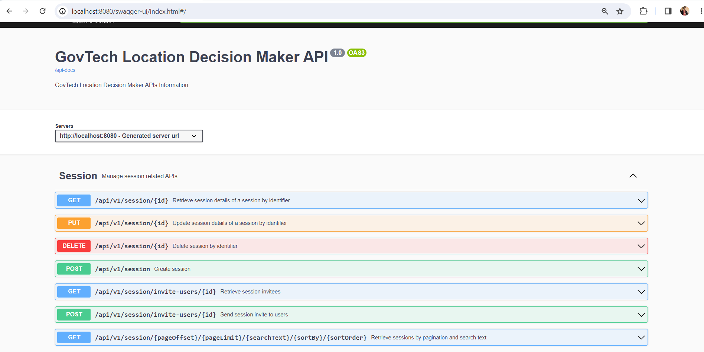

* 1. **GET**[**/api/v1/session/{id}**](http://localhost:8080/swagger-ui/index.html#/Session/getById_1)

**Description**: Retrieve session details of a session by identifier

* 1. **PUT**[**/api/v1/session/{id}**](http://localhost:8080/swagger-ui/index.html#/Session/update)

**Description**: Update session details of a session by identifier

* 1. **DELETE**[**/api/v1/session/{id}**](http://localhost:8080/swagger-ui/index.html#/Session/delete)

**Description**: Delete session by identifier

* 1. **POST**[**/api/v1/session**](http://localhost:8080/swagger-ui/index.html#/Session/create_1)

**Description**: Create session

* 1. **GET**[**/api/v1/session/invite-users/{id}**](http://localhost:8080/swagger-ui/index.html#/Session/getInvitees)

**Description**: Retrieve session invitees

* 1. **POST**[**/api/v1/session/invite-users/{id}**](http://localhost:8080/swagger-ui/index.html#/Session/invite)

**Description**: Send session invite to users

* 1. **GET**[**/api/v1/session/{pageOffset}/{pageLimit}/{searchText}/{sortBy}/{sortOrder}**](http://localhost:8080/swagger-ui/index.html#/Session/find_1)

**Description**: Retrieve sessions by pagination and search text

1. **Restaurant Management APIs:**

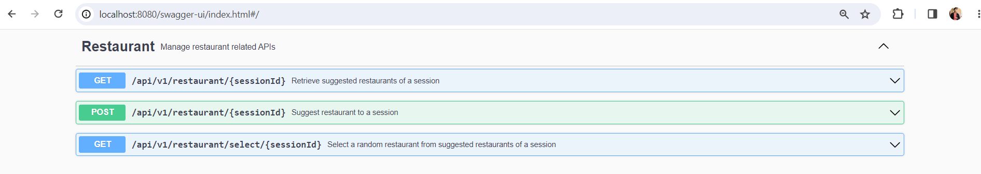

* 1. **GET**[**/api/v1/restaurant/{sessionId}**](http://localhost:8080/swagger-ui/index.html#/Restaurant/getSessionSuggestRestaurants)

**Description**: Retrieve suggested restaurants of a session

* 1. **POST**[**/api/v1/restaurant/{sessionId}**](http://localhost:8080/swagger-ui/index.html#/Restaurant/suggestRestaurantToSession)

**Description**: Suggest restaurant to a session

* 1. **GET**[**/api/v1/restaurant/select/{sessionId}**](http://localhost:8080/swagger-ui/index.html#/Restaurant/selectSessionSuggestRestaurant)

**Description**: Select a random restaurant from suggested restaurants of a session